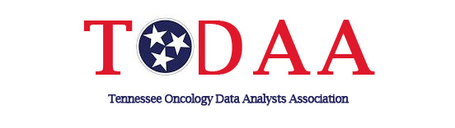
TODAA Today (Fall 2021 edition)

Your response is appreciated and requested-see deadlines below.

FREE Virtual Annual Meeting-
Register today our FREE Virtual Annual Conference being held on October 20, 2021.

Agenda:

Registration:

2022 Officer nominations-
It’s that time Please submit any names for the 2022 ballot to one of our following nominating committee officers by the September 15 deadline. The rolls on the ballot for 2022 are: Vice-president, Regional representatives for east, middle, and west areas. Regional nominating committee for east, middle and west areas. Please see the bylaws and operations manual on the following website to learn more about each role or feel free to contact the serving member in the role. http://www.todaa.org/

Shari Findlay-East shar.taz68@gmail.com
Bria Readus-Middle bria.readus@tn.gov
Charlene Fulton-West charlene.r.dixon@gmail.com

Bylaws-
Submit any proposed bylaws changes to Debbie Brooks at vdbrooks85@gmail.com , by the September 15 deadline.

New 2021 CTR members-Kindly send your picture to Leighann Jones at ljones@covhlth.com by October 10 deadline. We would like to recognize you at our October 20 business meeting.
________________________________________________________________________________
Submit your ideas and information for future TODAA editions to Tonya Davis-Myers at tdmyers222@gmail.com. Announcements of new CTR’s, job opportunities, etc.

