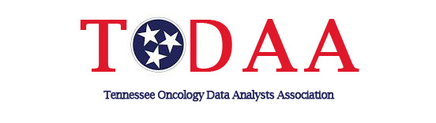
TODAA Today (Summer 2021 edition)

Virtual meetings-
Mark your calendar for our Virtual Annual Conference being held on October 20, 2021.

Speakers include: CoC State of TN Chair, Dr. James McLoughlin, MD, FACS
Vanderbilt Medical Center- Dr. Cathy Eng, MD, FACP, FASCO
Tennessee Cancer Registry- Martina Manis BS, RHIA, CTR
Cancer Registrar III/Educational Coordinator
Southwest Wisconsin Technical College-Sara Biese, RHIT, CTR
Cancer Information Management Program Director and Instructor
Health Information Management Instructor
Himagine Solutions -Janet Vogel, CTR
Compliance & Quality Auditor/Educator

More information to come soon!

2022 Officer nominations-
Be thinking about fellow members or even running for office yourself in 2022. Please feel free to submit any names for the ballot to one of our following nominating committee officers:

Shari Findlay-East shar.taz68@gmail.com
Bria Readus-Middle bria.readus@tn.gov
Charlene Fulton-West charlene.r.dixon@gmail.com

Congratulations-
Leslie Stroud will be serving NCRA in one of the Council on Certification Representatives positions. Congratulations Leslie!!!

New CTR-
Congratulations to Heather Shipley on obtaining her certification!

Virtual Regional Meeting Information-
Thank you to our speakers for your willingness to speak. Our follow-up survey to registrants were all positive. Slides from the conference have been posted to the members only section on the website for your viewing.

Membership- Thank you for updating your membership, we currently have 109 members.
________________________________________________________________________________
Submit your ideas and information for future TODAA editions to Tonya Davis-Myers at tdmyers222@gmail.com. Announcements of new CTR’s, job opportunities, etc.

