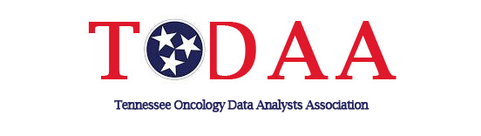

**TODAA Today (Winter 2021 edition)**

**Presenting your** **2022 Officers:**

    

Shawna Brewster Kerry Osborne Dawn Rychlik Cynthia “Renee” Parker Edie Knapp

East Nominating Middle Nominating West Nominating East Representative Middle Representative

    

Charlene Fulton Leigh Ann Jones Linda Reagan Leslie Stroud Ying Qi

West Representative Immediate Past President Vice President Secretary/Treasurer

President

**Reminder:** Please take a moment to do a two-minute quick check and update your profile on the website-we want to ensure that you receive all communication in the upcoming year and that our members information is up to date. Thank you! https://todaa.wildapricot.org/

**Membership Renewal- Kindly go ahead and renew your membership for 2022 before the holidays to ensure that the you receive all TODAA communication for 2022.** [**https://todaa.wildapricot.org/join-us.htm**](https://todaa.wildapricot.org/join-us.htm)

**2021 Education Conferences- We had 76 members who attended our virtual Regional Conference and 96 attendees who attended our virtual Annual Conference. 2021 Education power points are in the members only section for your use.**

**Thank you to everyone who responded to the survey monkeys throughout the year. Your responses helped make this year a successful one for our organization😊**

________________________________________________________________________________

Submit your ideas and information for future TODAA editions to Leigh Ann Jones @ ljones@covhlth.com. Announcements of new CTR’s, job opportunities, etc.